**GraphQL**

Relationships between objects referred to as “edges”

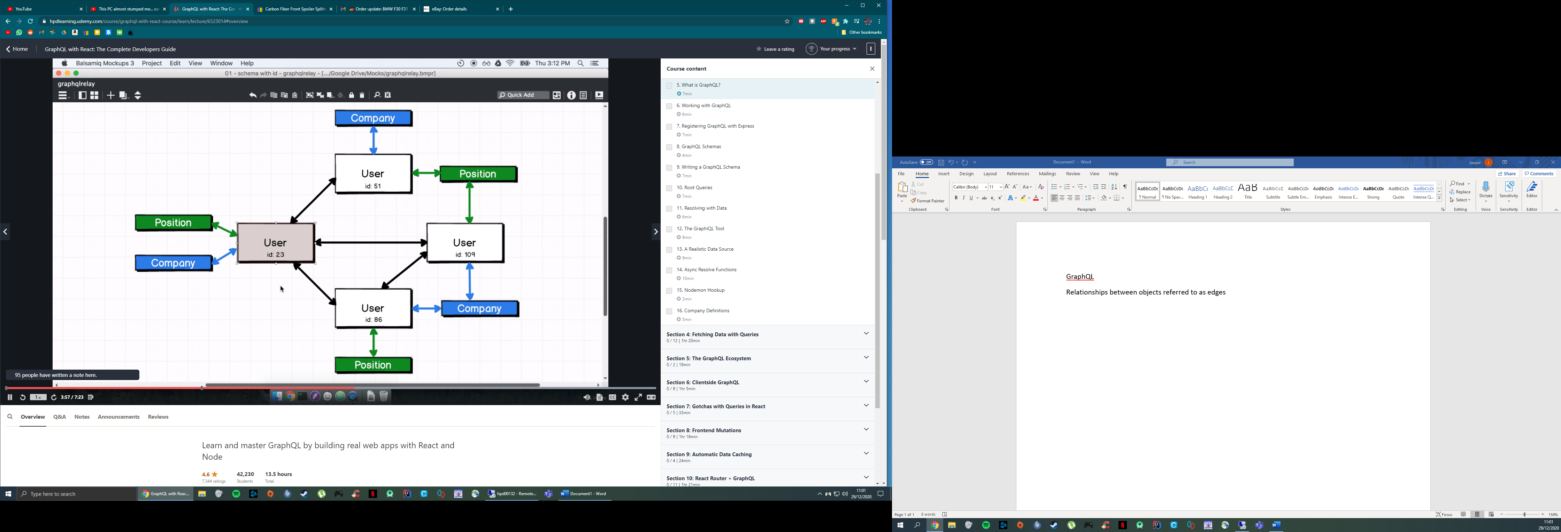

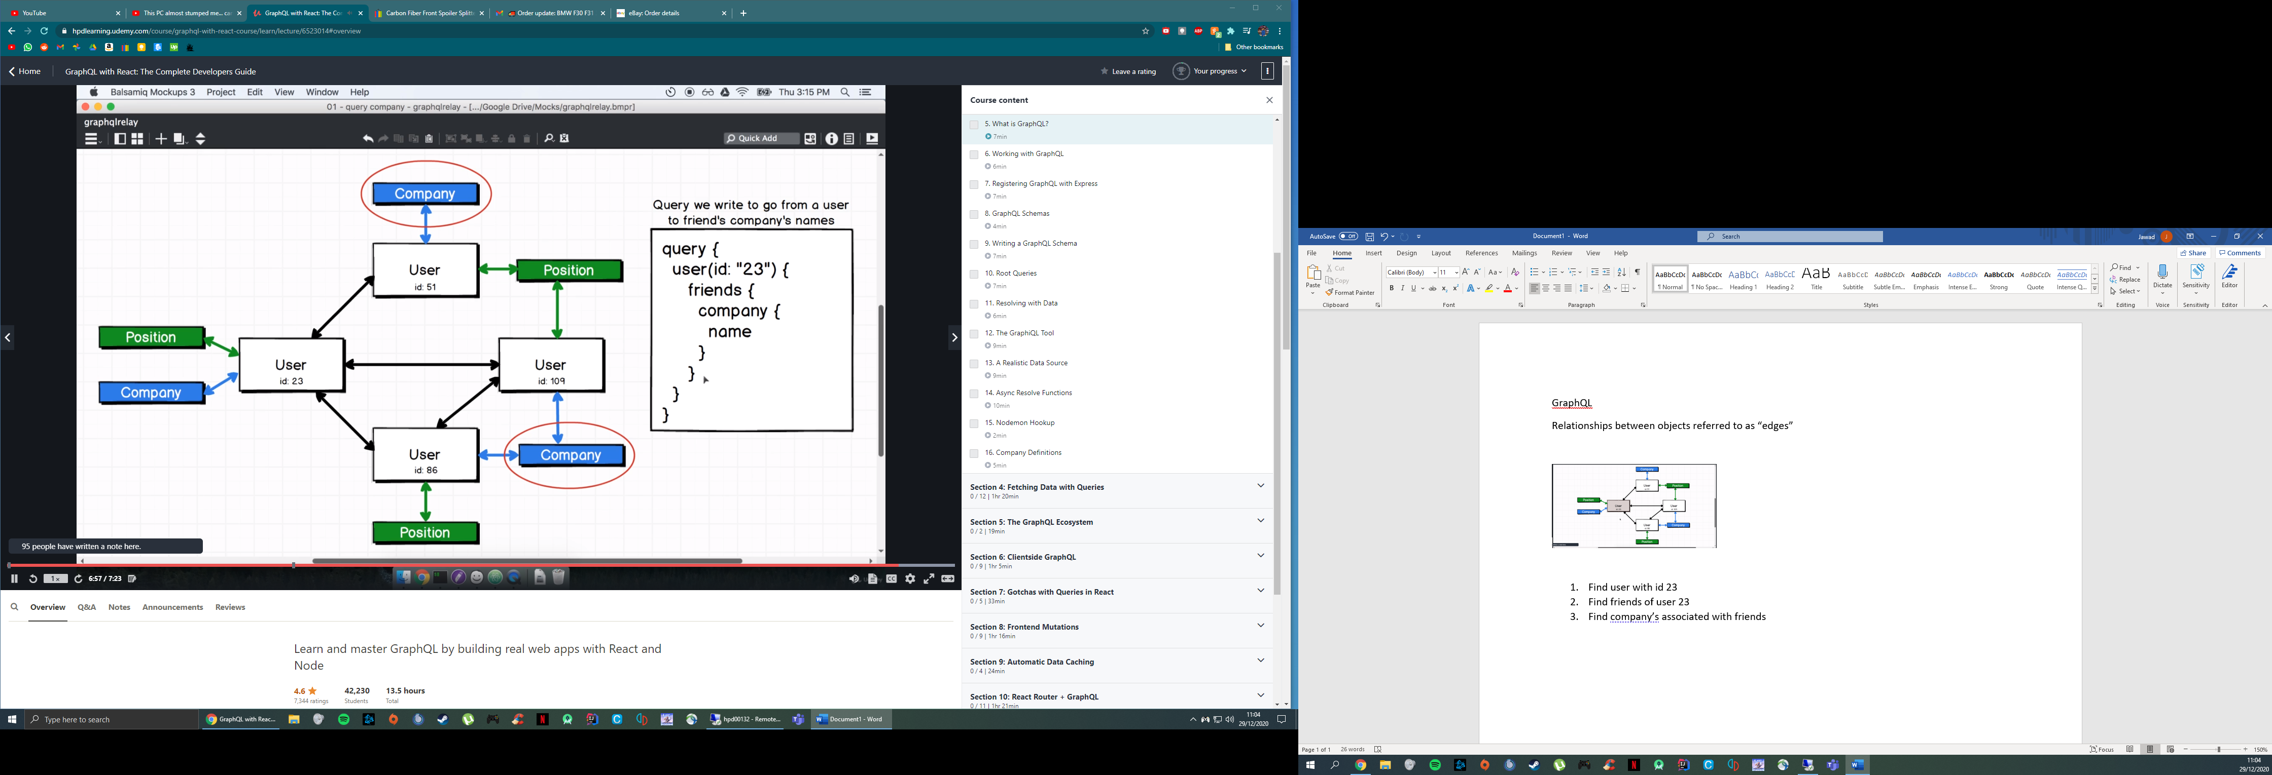

1. Find user with id 23
2. Find friends of user 23
3. Find company’s associated with friends

Root query is the “entry point” into data